Exhibit B

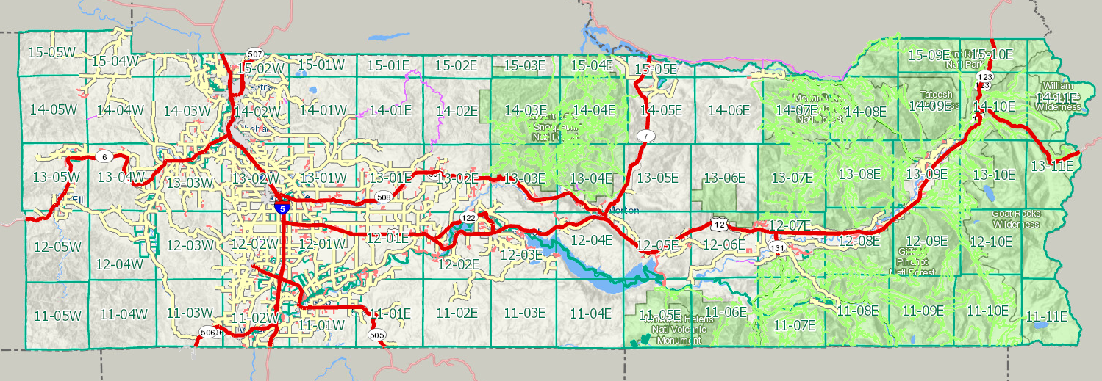
Franchise Area

Exhibit C
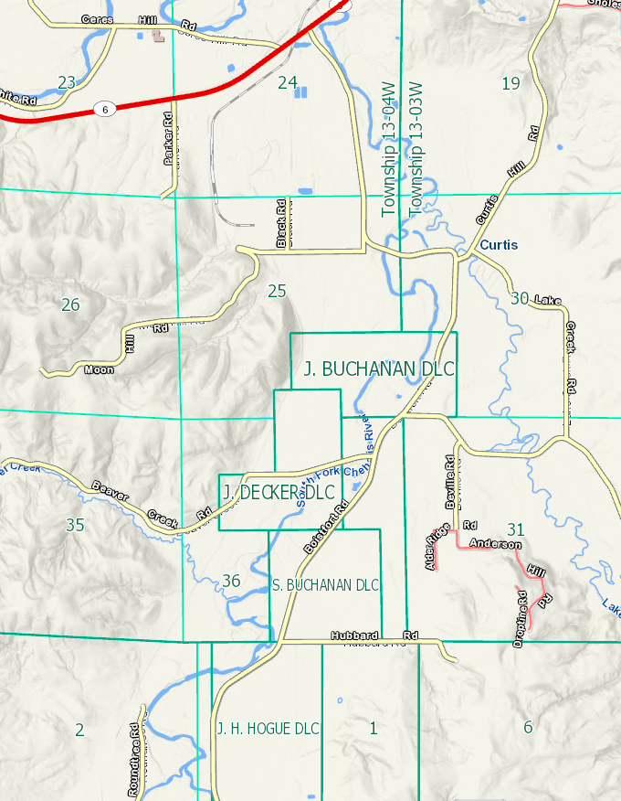
Hubbard Rd
Roundhouse Rd
Beville Rd
King Rd
Boistfort Rd
Moon Hill Rd
Black Rd
Lake Creek Rd
Curtis Hill Rd
Franchise Area
Exhibit D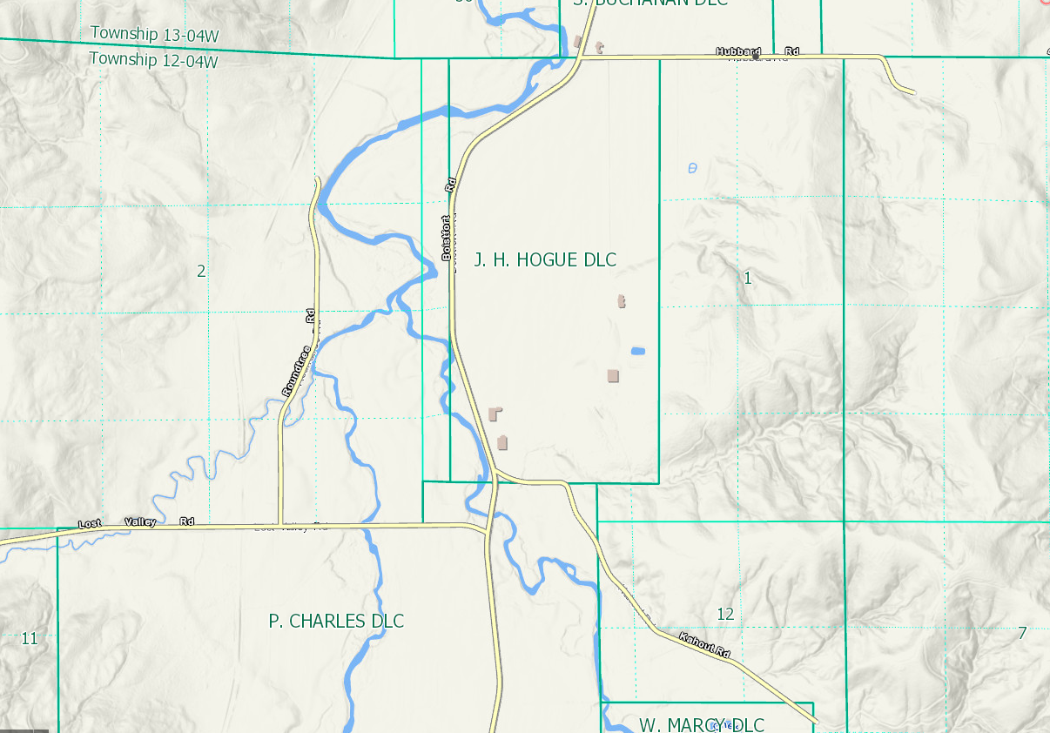
Roundhouse Rd
Lost Valley Rd
Kahout Rd
Boistfort Rd
Hubbard Rd
Franchise Area
Exhibit E
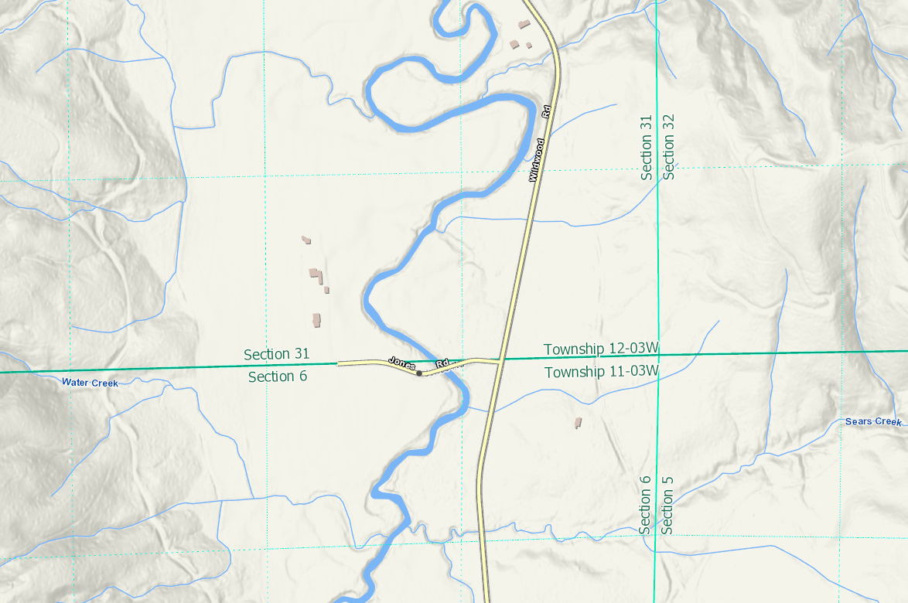
Wildwood Rd
Jones Rd
Franchise Area
Exhibit F
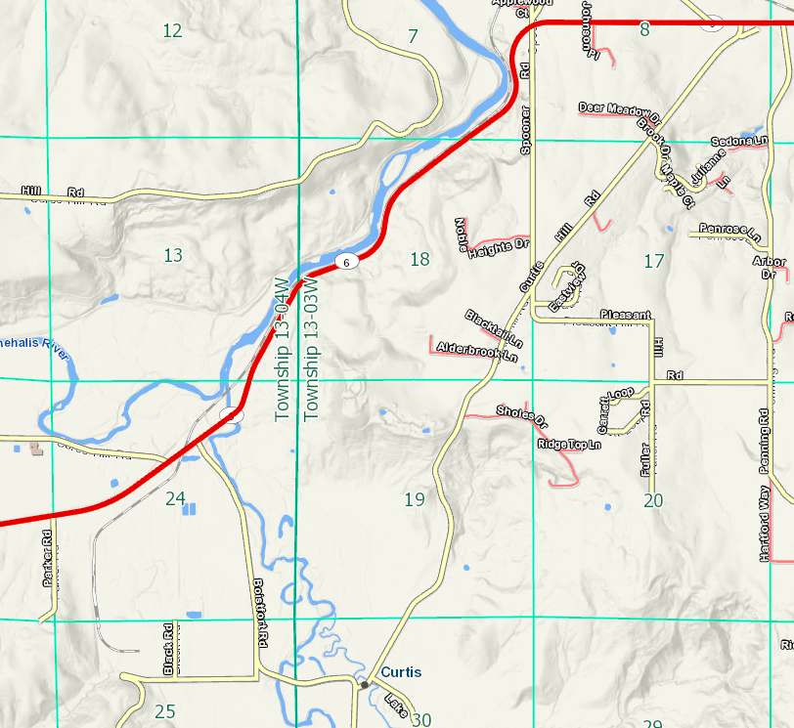
Curtis Hill Rd
Boistfort Rd
Lake Creek Rd
Moon Hill Rd
Black Rd
Franchise Area
Exhibit G
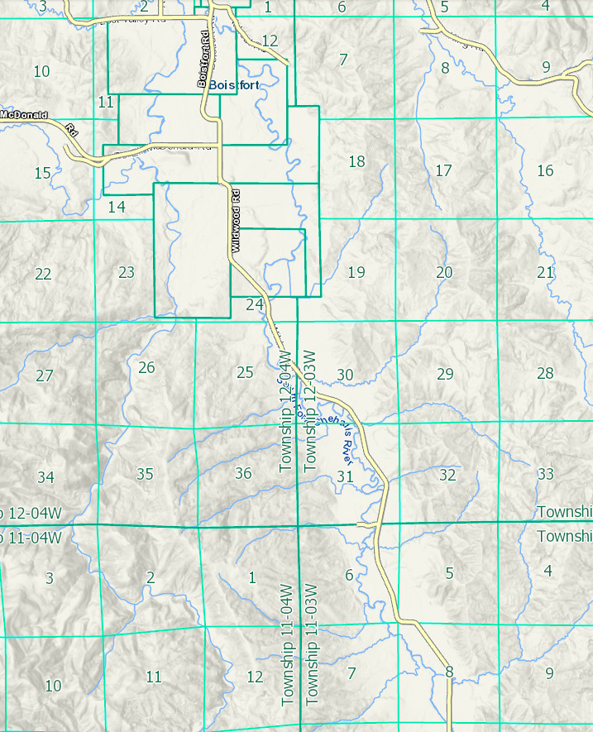
Jones Rd
Wildwood Rd
Moorecroft Rd
Pe Ell McDonald Rd
Roundhouse Rd
Lost Valley Rd
Boistfort Rd
Kahout Rd
King Rd
Burri Rd
Franchise Area
Exhibit H
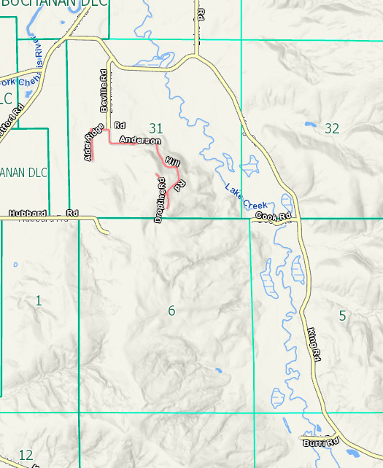
Beville Rd
Boistfort Rd
Hubbard Rd
Burri Rd
King Rd
Lake Creek Rd
Franchise Area

