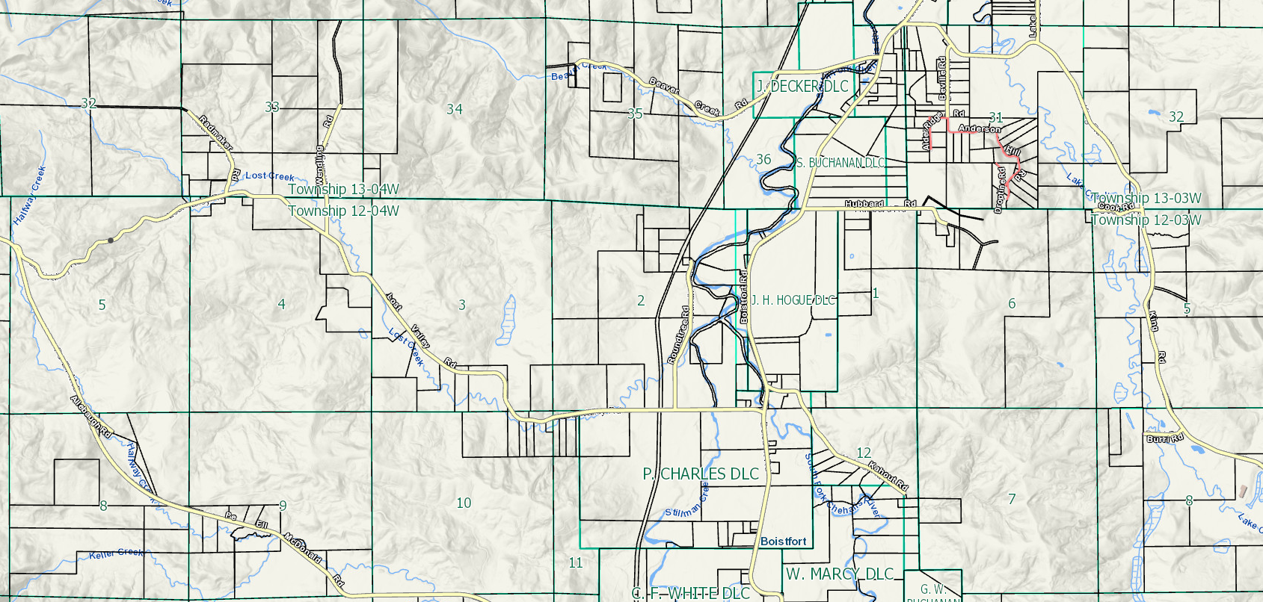
Township 12 North, Range 4 West, W.M.
&
Township 13 North, Range 4 West, W.M.

Franchise Area
Wendling Rd.
Lost Valley Rd.
N

