CALL FOR BIDS

ONE (1) TRUCK-MOUNTED ENCLOSED SERVICE BODY

TO:
LEWIS COUNTY HISTORIC COURTHOUSE
BOARD OF COUNTY COMMISSIONERS OFFICE
351 NW NORTH STREET
CHEHALIS, WASHINGTON 98532

BID OPENING:
WHERE: Lewis County Historic Courthouse
Board of County Commissioners Meeting Room
351 NW North Street
Chehalis, Washington 98532

DATE: March 17, 2020

TIME: On or after 11:00 AM

BID PACKET CONTENTS

CALL FOR BIDS

ADVERTISING PLAN

BID FORM

BID DOCUMENT CHECKLIST

GENERAL CONDITIONS

SPECIFICATIONS / ITEMIZED OPTIONS

1.

CALL FOR BIDS

CALL FOR BIDS

NOTICE IS HEREBY GIVEN that the Board of County Commissioners of Lewis County, Washington will open sealed bids and publicly read them aloud on or after 11:00 a.m. on March 17, 2020, at the Lewis County Historic Courthouse – 2nd floor, Board of County Commissioners Meeting Room, 351 NW North Street, Chehalis, Washington, for furnishing one (1) Truck-Mounted Enclosed Service Body.
SEALED BIDS MUST BE DELIVERED BY 11:00 A.M.
(Lewis County official time is displayed on Axxess Intertel phones in the office of Board of County Commissioners.)

Sealed bids must be delivered to the Lewis County Commissioner’s Office (Lewis County Historic Courthouse, 2nd Floor, 351 NW North Street, Chehalis, WA 98532) by 11:00 a.m. on the date specified for opening and in an envelope clearly marked "SEALED BID FOR ONE (1) TRUCK-MOUNTED ENCLOSED SERVICE BODY” - TO BE OPENED MARCH 17, 2020 ON OR AFTER 11:00 AM.
Specifications and bid forms may be obtained from Lewis County Department of Public Works Fleet Division located at 476 W. Main St., Chehalis, WA 98532, telephone 360-740-1194 or from Lewis County’s website at www.lewiscountywa.gov.
The Lewis County Public Works Department in accordance with Title VI of the Civil Rights Act of 1964, 78 Stat. 252, 42 U.S.C. 2000d to 2000d-4 and Title 49, Code of Federal Regulations, Department of Transportation, subtitle A, Office of the Secretary, Part 21, nondiscrimination in Federally assisted programs of the Department of Transportation issued pursuant to such Act, hereby notifies all bidders that it will affirmatively ensure that in any contract entered into pursuant to this advertisement, disadvantaged business enterprises as defined at 49 CFR Part 26 will be afforded full opportunity to submit bids in response to this invitation and will not be discriminated against on the grounds of race, color, or national origin, or sex in consideration for an award.
The Board of County Commissioners reserves the right to reject any or all bids and to waive all informalities in the bidding.

DATED this 2nd day of MARCH 2020.
_____________________________________
Clerk of the Board of County Commissioners
Lewis County, Washington

PUBLISH: The Chronicle – March 3 & 10, 2020

Lewis County Web Site @ www.lewiscountywa.gov/

2.

ADVERTISING PLAN

ADVERTISING PLAN

The Call for Bids will be advertised in the following publications:

- The Chronicle - Tuesday, March 3 & 10, 2020

Bid information will also be available on the Lewis County website at www.Lewiscountywa.gov

3.

BID FORM

LEWIS COUNTY PUBLIC WORKS DEPARTMENT
FLEET SERVICES DIVISION
476 W. MAIN ST.
CHEHALIS, WA 98532

The Board of Lewis County Commissioners will open sealed bids and publicly read them aloud at the Lewis County Historic Courthouse-2nd floor, Board of County Commissioners Meeting Room, 351 NW North Street, Chehalis, Washington, on:

TUESDAY, MARCH 17, 2020 ON OR AFTER 11:00 A.M.

For the following specified items:

ONE (1) TRUCK-MOUNTED ENCLOSED SERVICE BODY

Sealed bids must be delivered to the Lewis County Historic Courthouse – 2nd Floor, Board of County Commissioner’s Office, 351 NW North Street, Chehalis, Washington, 98532, by 11:00 A.M. on the above-specified date in a sealed envelope clearly marked:

SEALED BIDS FOR: ONE (1) NEW TRUCK-MOUNTED ENCLOSED SERVICE BODY
TO BE OPENED: TUESDAY, MARCH 17, 2020 ON OR AFTER 11:00 A.M.

BID FORM

SEE ATTACHED CONDITIONS AND SPECIFICATIONS

- ONE (1) TRUCK-MOUNTED ENCLOSED SERVICE BODY $______________

- WASHINGTON STATE SALES TAX + $______________

- PURCHASER PAYS THIS AMOUNT = $______________

Guaranteed delivery shall be within sixty (90) days after award of bid.

____________________________ ________________________________ Bidder Authorized Signature Date

____________________________ ________________________________
Firm Address Title of Person Signing

____________________________ ________________________________ City, State Zip Telephone Number

4.

BID DOCUMENT CHECK LIST

The following items must be returned in the completed bid package:

1. _______ BID FORM (Pg. 9)

2. _______ TERMS, CONDITIONS, & SPEC Acknowledgement (Pg. 15)

3. _______ LIST OF REFERENCES

(Complete name, address and phone number of three customers who

have purchased similar equipment within the last two (2) years.

4. ______ SPECIFICATIONS SHEET (Complete Check-List on Pg. 17)

5.

GENERAL CONDITIONS

GENERAL CONDITIONS

BID CONSIDERATION:
The Board of Lewis County Commissioners reserves the right to reject any or all bids, waive informalities, and to contract as the best interest of the County may appear. This bid will be compared to bids received on the Washington State Contract. Commissioners reserve the right to award to the most advantageous bid to the County.

DOCUMENT FORM:
The bidder shall completely fill in the information required in all the blank spaces provided and shall return all forms and other documentation requested when submitting bid forms. Information may be obtained from the Department of Public Works, Maintenance & Operations Division, 476 W. Main St., Chehalis, WA 98532, telephone 360-740-1194 or Lewis County’s website at www.lewiscountywa.gov.

PROPOSAL SHEET:
Vendors not meeting specifications must list all exceptions and note by placing an “X” beside the respective number associated with the particular specification. Any exceptions are subject to inspection, testing, and approval prior to acceptance by Lewis County.

Truck-mounted enclosed service body shall be new and shall:
1. Conform to or exceed the minimum specifications listed.
2. Comply with the current Federal Equipment Safety Standards.
3. Shall meet the manufacturer’s standard specifications and shall be further equipped as stated in these specifications whether considered standard or not.

PAYMENT:
Payment will be made by Lewis County on or about 30 days following date of delivery, providing billing invoice is in the office of the Lewis County Fiscal Department, 351 NW North Street, Chehalis, WA 98532 prior to the 10th of the month.

PRE-DELIVERY:
All items shall receive dealer factory pre-delivery service before being delivered. Transportation damage shall be repaired by dealer prior to delivery. All equipment will be in turnkey condition and subject to inspection prior to acceptance.

DELIVERY OF EQUIPMENT PURCHASES:
Packing and transportation expenses are the responsibility of the bidder, IF, the bidder is more than 150 miles from the address listed below. If more than 150 miles from 476 W. Main St. Chehalis, Washington, all prices quoted must be F.O.B. Destination, Freight Prepaid and Allowed, delivered and unloaded (picked up & delivered) at the delivery address below.

Lewis County Motor Pool 476 W. Main St. Chehalis, WA 98532

LITERATURE:
Descriptive brochure with reasonably detailed specifications for the unit offered must be enclosed with the bid documents.

COOPERATIVE PURCHASES:
Lewis County has entered into Interlocal Purchase Agreements with other governmental agencies pursuant to RCW 39.34. Successful bidder, if agrees, can sell additional items at the bid price, terms and conditions to other governmental agencies. Lewis County accepts no responsibility for the payment of the purchase price by other governmental agencies.

PROPOSAL:
The undersigned hereby certifies that he/she has read and thoroughly understands and agrees to the terms, conditions, and specifications of this document for furnishing the item(s) listed to Lewis County and hereby submits the proposal on page 9.

___________________________ ___________________________________________ Firm Name (Type or Print) Authorized Signature Date

___________________________ ___________________________________________ Title of Person Signing Telephone Number

___________________________ ___________________________________________ Address City, State, Zip Code

6.

SPECIFICATIONS

&

ITEMIZED OPTIONS

- Specifications Check-List:
Truck-Mounted Enclosed Service Body shall be new. Chassis shall be picked up and delivered (if more than 150 miles away), and in turnkey condition. Enclosed Service Body will be installed on a 2019 Dodge RAM-4500, Crew Cab, 4x4, Dual rear wheels, 84” Cab-to-axle, with gasoline engine.
(“Delivery address listed on page 14”)
Make ___________________ Model ___________________ Year ___________________

Minimum Specification Required | List Specification Provided
Enclosed Service Body:
Service Body 11’ in length and approximately 90” in height, and Installed on Lewis County’s Truck Chassis (2019 Dodge RAM-4500 Crew Cab, 4x4, 84”CA)
Body shall be painted white
Two (2) Adjustable Divider Shelf, street & curb side FRONT vertical compartments
One (1) Adjustable Divider Shelf, street & curb side REAR vertical compartments
One (1) Adjustable Divider Shelf, curb side horizontal compartment
Two (2) Full-length shelves each side in interior of body (one on top of compartment and one fixed shelf in roof).
Rivetless Rotary slam latches on all side doors with double spring over center door retainers on all vertical doors
Double Panel Galvanneal Rear Doors with rivetless latch and solid panel with no glass
Two (2) Rear Access Doors with rivetless latches on upper roof structure
24” Tail-shelf installed on rear of service body – Shall include side access doors, side and center light hole panels
Electrical:
Lighting shall be LED, and installed per DOT regulations
Four (4) Corner amber/white strobes wired to up-fitter switch in cab.
- (2) Front, Mounted to Grill
- (2) Rear, Mounted to Rear at customer specified location
Complete surface mounted light kit with 6-circuit wire harness, all required lights, and 2 interior LED dome lights – All lights installed, wired, and switched
No scotch-locks shall be used in wiring
All rear exterior lighting to be installed on tail-shelf
Exterior Finish:
Service Body shall be coated with quality primer, and painted white
No welding scale, roughness, sharp corners, or rust stains on delivered unit.
Lewis county expects professional workmanship from vendors. The finishing requirements will be monitored closely in the final product.
Misc:
Shall include a Class V Hitch with 2” Receiver and 7-way plug (RV Style)
Install OEM supplied Back-up Camera
Install Dual Cone Holders – Mounted to front of truck cab
Provide weight/scale slip for completed truck chassis and service body unit

ITEMIZED OPTIONS:

** DO NOT include these prices in base bid submitted on page 9 **

Options / Accessories / (Adds/Deletes)

- Two (2) Dodge/Chrysler Codeable Padlocks for Service Body doors – (includes a full-length rod system on each side of body. Allows all locks to be unlocked at the same time on each side. $_____________

- Remote Keyless entry for Service Body doors $ ____________

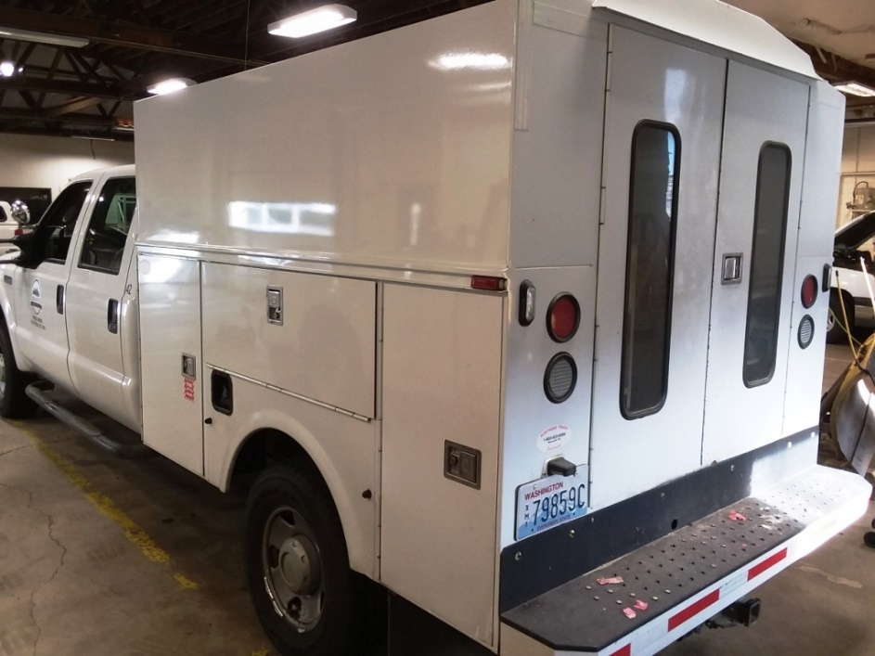
Photo of unit being replaced

