Shipping Address (job site): 125 NW Chehalis Ave, Chehalis, WA 98532

Bid to Include: RTA Cabinet Kits (as detailed below), shipping, and delivery to the job site (address listed above)

Estimates must be submitted through OpenGov.com
- Create an account: https://procurement.opengov.com/portal/lewiscountywa
- Submit bid at: https://procurement.opengov.com/portal/lewiscountywa

RTA (Ready to Assemble) Cabinet Details/Specs:
- Color: White
- Plywood Box Bases, Minimum ½" thick Plywood
- Solid Wood Door and Drawer Faces
- Dovetail Construction for Drawers
- Soft Close Doors and Drawers
- Cabinet Door Style: Prefer Flat Panel Front, 2nd Choice Shaker Style

Item # | Cabinet Style | Type | Width | Depth | Height | Quantity
1. | 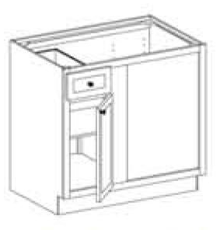 | Base  Blind Corner  Blind on RIGHT | 42” Wide | 24” Deep | 34 ½” Tall | (1)
2. |  | Base  Blind Corner  Blind on LEFT | 42” Wide | 24” Deep | 34 ½” Tall | (2)
3a.  3b. | 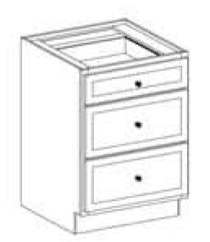 | Base  3 Drawer | 24” Wide  18” Wide | 24” Deep  24” Deep | 34 ½” Tall  34 ½” Tall | 3a. (7)  3b. (2)
4. | 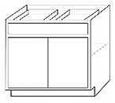 | Base  Double Door w/ Double Drawer | 24” Wide | 24” Deep | 34 ½” Tall | (11)
5. | 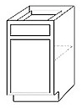 | Base  Single Door w/ Single Drawer | 18” Wide | 24” Deep | 34 ½” Tall | (5)
6. | 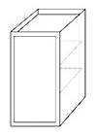 | Upper/Wall  Single Door | 18” Wide | 12” Deep | 42” Tall | (4)
7. | 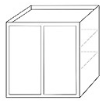 | Upper/Wall  Double Door | 24” Wide | 12” Deep | 42” Tall | (2)
8. | 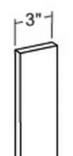 | Upper Cabinet  Filler 3” | 3” |  | 42” Tall | (4)
9. | 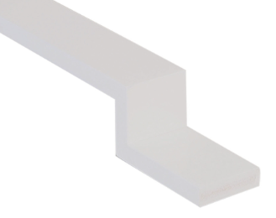 | Base Cabinet  Filler 3” | 3” |  | 34 ½” Tall | (6)

