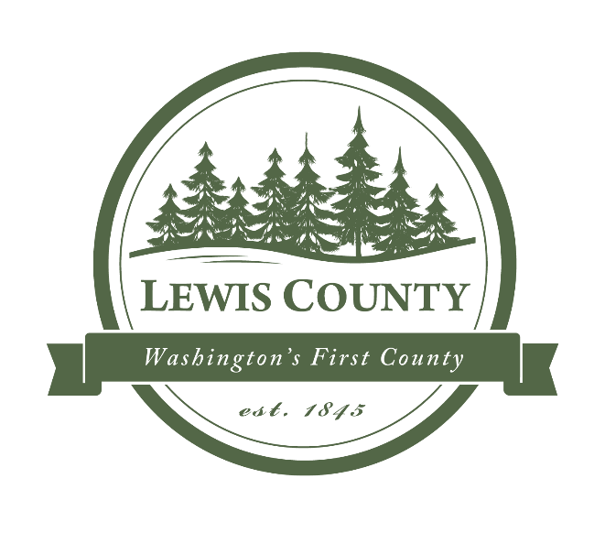

**LEWIS COUNTY NOTICE FOR:**

**Request for Proposals (RFP)**

**RFP for VHF Radio Infrastructure Engineering Studay, a project funded by the Coronavirus State and Local Fiscal Recovery Funds (SLFRF) program, a part of the American Rescue Plan.**

Proposals must be marked “VHF Engineering Study” Attention: Jennifer Libby-Jones and be delivered to Lewis County 911 Communication, 351 NW North St., Chehalis, WA 98532.

Lewis County desires to engage a qualified and experienced radio engineering firm to provide a VHF infrastructure engineering study and recommendatioins on improving the existing public safety communications system in Lewis County.

**CLOSING DAY AND TIME: Responses will be accepted no later than 4:00 p.m. on February 23, 2023.**

The proposals must be submitted with a master (marked “Original”) and four (4) copies (marked “Copy”) and one jump/flash drive or email with a copy of the proposal downloaded. Completed proposal packets are limited to ten (10) pages, double-sided if needed.

For more information about the project and submittal requirements, contact Jennifer Libby-Jones at [jennifer.libby-jones@lewiscountywa.gov](mailto:jennifer.libby-jones@lewiscountywa.gov) or at 360-740-3394.

DATED this 10th of January, 2023.

______________________________________

Clerk of the Board of County Commissioners

Lewis County, WA

PUBLISH: The Chronicle Thurs 1/12/23; The Seattle Daily Journal of Commerce Thurs 1/12/23; The Portland Daily Journal of Commerce Wed 1/11/23

Lewis County website @www.lewiscountywa.gov