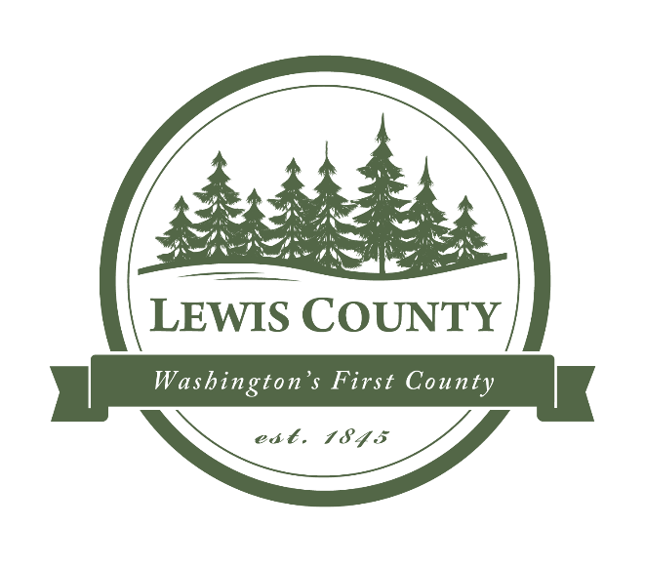
Request for Proposal Packet for:

Lewis County Parks and Recreation
Playground Equipment
and Installation

OFFERED BY:
LEWIS COUNTY
DEPARTMENT OF PARKS AND RECREATION
1909 S. Gold Street
Centralia, WA 98531

Bidding Instructions:

Proposals must be sealed and clearly labeled as:
“Playground Proposal” and delivered by 4:00 PM on the due date. Proposals may be mailed or hand delivered to Lewis County Parks and Recreation Office:

Mailing & Physical Address:

Lewis County Parks & Recreation
1909 S. Gold St.
Centralia, WA 98531

SEALED BIDS MUST BE DELIVERED BY OR BEFORE
4:00 P.M. on Wednesday, March 9, 2022
(Lewis County official time is displayed on Mitel phones in the Parks & Rec Office. Bids submitted after 4:00 PM will not be considered for this project.)

DOCUMENT CHECK LIST

(Lewis County Forms Only)

The following items must be returned

in the completed bid package:

Signed Proposal including Pricing Table in format of RFP Request.
Notice of Prevailing Wage Requirement
This project has been determined to be “Public Works” as defined by RCW 39.04 and WAC 296-127 and is subject to Washington State Prevailing Wage Laws. Current Prevailing Wage Rates for work performed in Lewis County are attached. These rates may not apply to work performed outside Lewis County. In addition, successful Contractor may be required to produce Certified Payroll Records upon request. There are exceptions to the prevailing wage requirements specified in the above RCW and WAC.

Section I: Company information and project details

Company information
Lewis County Parks & Recreation |  |  | Playground Equipment Purchase & Installation
RFP date issued: Feb 23, 2022 |  |  | Response deadline (received by): March 9, 2022; 4:00 pm
Contact information
Project lead name |  |  | Phone |  | Email
Connie Riker, Director |  |  | 360-740-2656 |  | Connie.Riker@lewiscountywa.gov
Project information
Project description | Purchase of playground equipment for 5 parks in Lewis County, WA.  Park #1 – Schaefer Park, 822 WA-507, Centralia, WA 98531  Park #2 – Rose Park, Penning Road, Chehalis, WA 98532  Park #3 – South County Park, 212 Ray Rd, Toledo, WA 98591  Park #4 – Back Memorial Park – Items ordered for distribution to this and other parks that our staff will install  Park #5 – Fairgrounds Park – 1909 So Gold Street, Centralia, WA 98531
Project goals | To have playground equipment installed in each park to be used the 2022 outdoor park season for the community to enjoy.
Submission instructions | Mail sealed bids to:  Connie Riker  Lewis County Parks & Recreation  1909 South Gold Street  Centralia, WA 98531  Bids must include a total cost, which includes product, installation, tax, and shipping.

Section II: Specifications

Product information
Park 1 – All Quantity 1 each | Brooks Towers Play System  San Mateo Fitness Course Playground  Rockwell Teeter Duo in ground rider  Heavy Duty Arch Swing Set with 6 swings  Shark Spring Rider  Dino Rider Spring Rider  Charlie Chomper Fun Bouncer  JennSwing ADA Swing Seat
Park 2 – All Quantity 1 each | Terre Haute Fitness Course Playground  Motorcycle Spring Rider  Zebra Easy Rider  Bronco Easy Rider
Park 3 – All Quantity 1 each | Honolulu Playground  North Bethesda Fitness Course Playground  Rockwell Teeter Duo in Ground Rider  Heavy Duty Arch Swing Set with 6 swings  Frog Molded Spring Rider  Harry Hopper Fun Bouncer  Bumbling Betsy Fun Bouncer  JennSwing ADA Swing Seat  Granite Manor Play System
Park 4 – will not be installed – we will distribute to various parks & install | Extra Heavy Duty Picnic Table 8 ft vinyl dipped diamond pattern – Qty 15  ADA Single-Sided Extra Heavy Duty Picnic Table 8 ft vinyl dipped diamond pattern – Qty 5  Extra Heavy Duty Bench without Back 8 ft vinyl dipped diamond pattern – Qty 20  Extra Heavy Duty Bench without back 15 ft vinyl dipped diamond pattern – Qty 3  Rockwell Teeter Duo in Ground – Qty 1
Park 5 – Quantity specified with each item | Heavy Duty Arch Swing Set with 6 swings – Qty 1  Mustang Easy Rider – Qty 3  JennSwing ADA Swing Seat – Qty 1  Steamboat Springs Playground – Qty 1  Pony Easy Rider – Qty 3  Bronco Easy Rider – Qty 3  Pink Pony Easy Rider – Qty 2  Horse Spring Rider – Qty 2
Technical requirements | Bidder will be provided with area and diagram/layout of equipment for installation of purchased equipment and installation will not include supplying the footing material. Colors will be specified at time of order.

BID FORM

Section III: Bid Form – Bidder’s Complete & Return

Detailed pricing – All Items Including Tax & Shipping
Park | Product Cost Total $ | Install Cost Total $ | Expected Completion Date
Park 1 - Schaefer |  |  |  | Brooks Towers Play System  San Mateo Fitness Course Playground  Rockwell Teeter Duo in ground rider  Heavy Duty Arch Swing Set with 6 swings  Shark Spring Rider  Dino Rider Spring Rider  Charlie Chomper Fun Bouncer  JennSwing ADA Swing Seat
Park 2 - Rose |  |  |  | Terre Haute Fitness Course Playground  Motorcycle Spring Rider  Zebra Easy Rider  Bronco Easy Rider
Park 3 – South County |  |  |  | Honolulu Playground  North Bethesda Fitness Course Playground  Rockwell Teeter Duo in Ground Rider  Heavy Duty Arch Swing Set with 6 swings  Frog Molded Spring Rider  Harry Hopper Fun Bouncer  Bumbling Betsy Fun Bouncer  JennSwing ADA Swing Seat  Granite Manor Play System
Park 4 – Back & Misc. |  | NONE |  | Extra Heavy Duty Picnic Table 8 ft vinyl dipped diamond pattern – Qty 15  ADA Single-Sided Extra Heavy Duty Picnic Table 8 ft vinyl dipped diamond pattern – Qty 5  Extra Heavy Duty Bench without Back 8 ft vinyl dipped diamond pattern – Qty 20  Extra Heavy Duty Bench without back 15 ft vinyl dipped diamond pattern – Qty 3
Park 5 - Fairgrounds |  |  |  | Heavy Duty Arch Swing Set with 6 swings – Qty 1  Mustang Easy Rider – Qty 3  JennSwing ADA Swing Seat – Qty 1  Steamboat Springs Playground – Qty 1  Pony Easy Rider – Qty 3  Bronco Easy Rider – Qty 3  Pink Pony Easy Rider – Qty 2  Horse Spring Rider – Qty 2
Total

GRAND TOTAL FOR PROJECT: _______________

Section IV: Selection criteria

Selection information
RFP type – Sealed Proposal |  | Bid Opening Date – March 10, 2022 at 9:00 am PDT at the Parks & Rec Office 1909 South Gold St, Centralia, WA 98531
Additional criteria: Bids will be evaluated based on Completeness to Specifications, Price, and Anticipated Delivery Date of all items.

Section V: Terms and conditions

Terms & Conditions
Terms and conditions | County will pay no more than 50% of PRODUCT costs (not including installation) within 20 days of delivery of invoice after received with balance due (including installation costs) within 20 days of invoice sent after installation completion at each park. However, no more than 50% of total project installation costs for all parks will be paid until all installation is complete.

