EXHIBIT B

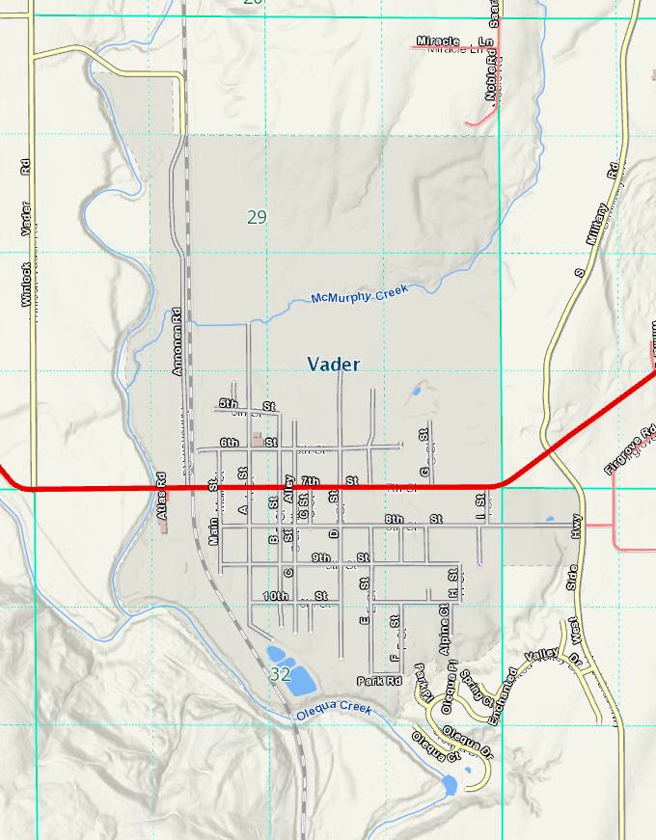
NORTH
Enchanted Valley Dr
Olequa Dr
Olequa Ct
Olequa Pl
Park Pl
Spring Ct
Enchanted Valley Dr S
Little Pinto Ct
West Side Hwy
S Military Rd
Annonen Rd
City of Vader
Hwy 506
Franchise Area

