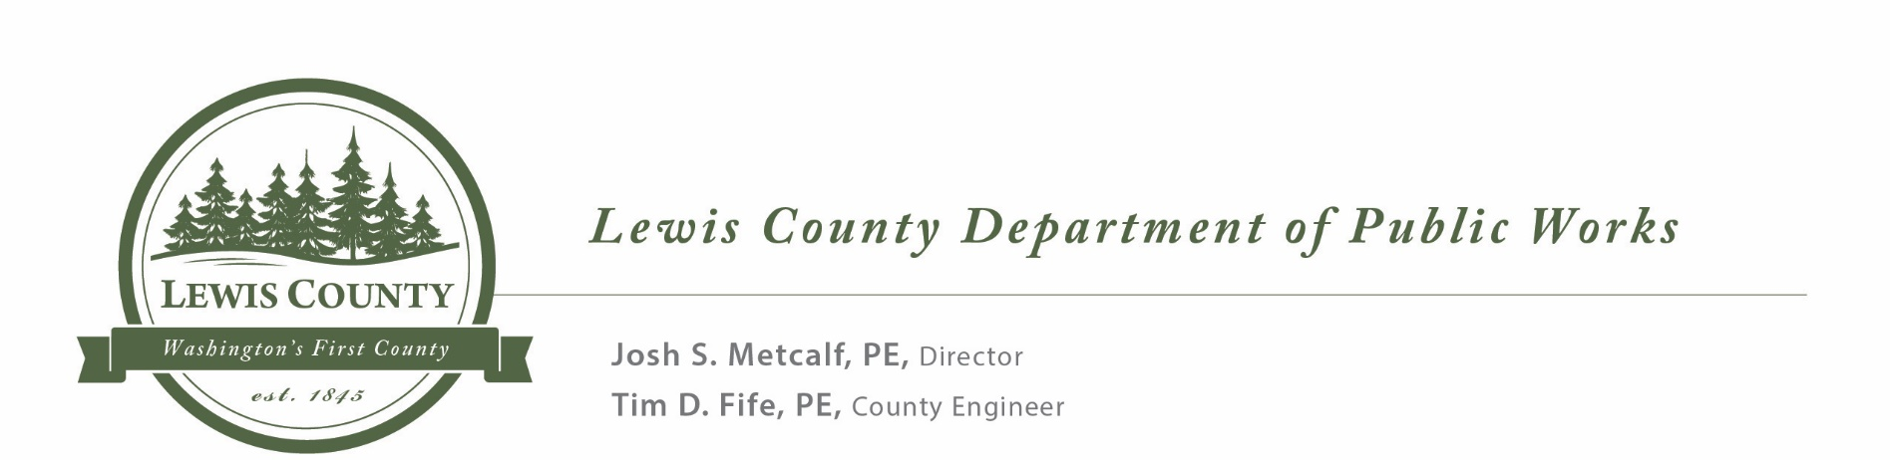

NOTICE TO CONTRACTORS

NOTICE IS HEREBY GIVEN that the Board of County Commissioners of Lewis County or designee, will open sealed proposals and publicly read them aloud on or after 12:15 p.m. on Thursday, July 15, 2021, at the Lewis County Courthouse in Chehalis, Washington for the Lincoln Creek Rd MP 13.7 Culvert Replacement Project, SM 20F100191370.

SEALED BIDS MUST BE DELIVERED BY OR BEFORE
12:15 P.M. on Thursday, July 15, 2021
(Lewis County official time is displayed on Axxess Intertel phones in the office of the Board of County Commissioners. Bids submitted after 12:15 PM will not be considered for this project.)

Sealed proposals must be delivered to the Clerk of the Board of Lewis County Commissioners (351 N.W. North Street, Room 210, CMS-01, Chehalis, Washington 98532), by or before 12:15 P.M. on the date specified for opening, and in an envelope clearly marked: “SEALED BID FOR THE LINCOLN CREEK RD MP 13.7 CULVERT REPLACEMENT PROJECT, SM 20F100191370, TO BE OPENED ON OR AFTER 12:15 P.M. ON THURSDAY, JULY 15, 2021.”

All bid proposals shall be accompanied by a bid proposal deposit in cash, certified check, cashier's check or surety bond in an amount equal to five percent (5%) of the amount of such bid proposal. Should the successful bidder fail to enter into such contract and furnish satisfactory contract bond within the time stated in the specifications, the bid proposal deposit shall be forfeited to the Lewis County Public Works Department.

Informational copies of maps, plans and specifications are on file for inspection in the office of the County Engineer of Lewis County in Chehalis, Washington. The contract documents may be viewed and downloaded from Lewis County’s Web Site @ www.lewiscountywa.gov or you may call the Lewis County Engineers office @ (360)740-2612 and request a copy be mailed to you. All Contractor questions and Lewis County clarifying answers will be posted on our website and emailed to all Contractors registered on Lewis County’s Planholder List. Plan or specification changes shall be accomplished through official project addendums.

The Lewis County Public Works Department in accordance with Title VI of the Civil Rights Act of 1964, 78 Stat. 252, 42 U.S.C. 2000d to 2000d-4 and Title 49, Code of Federal Regulations, Department of Transportation, Subtitle A, Office of the Secretary, Part 21, Nondiscrimination in Federally assisted programs of the Department of Transportation issued pursuant to such Act, hereby notifies all bidders that it will affirmatively ensure that in any contract entered into pursuant to this advertisement, disadvantaged business enterprises as defined at 49 CFR Part 26 will be afforded full opportunity to submit bids in response to this invitation and will not be discriminated against on the grounds of race, color, or national origin, or sex in consideration for an award.

If you need the Call for Bids for the Lincoln Creek Rd MP 13.7 project in Spanish please see our website at this address: https://cfb.lewiscountywa.gov/projects/

Si necesita el llamado a licitación para el proyecto Lincoln Creek Rd MP 13.7 en español, visite nuestro sitio web en esta dirección: https://cfb.lewiscountywa.gov/projects/

